NAME: **:**RAGAVENDIRAN S

REG NO:727721EUIT121

SOFTWARE TESTING CC2

YATRA:

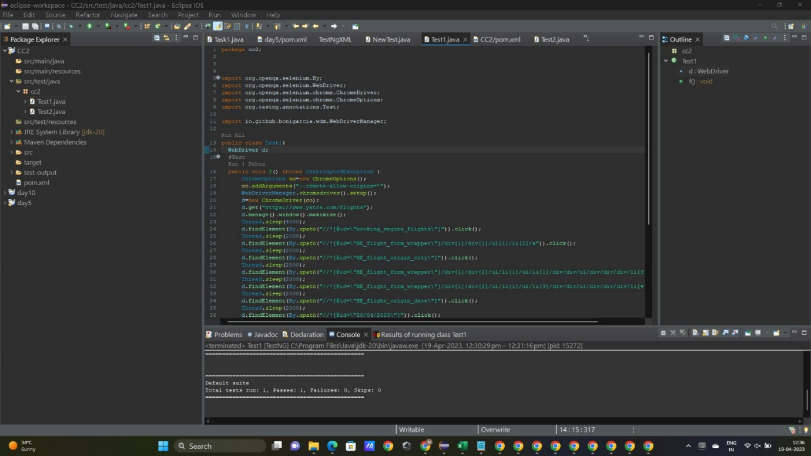



OUTPUT:

